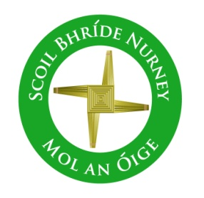

**School Self Evaluation Report**

**School Improvement Plan**

**2023/24**

**Process paused to focus on meeting the day-to-day health and safety requirements and practical challenges arising from the COVID-19 pandemic.**

* **The process was re-booted for the 2023/24 school year, continuing to follow the agreed timeline brought about through our whole school action research project on the process itself (2020 to 2022) and the targets identified in our School Self Evaluation Report (SSER) and School Improvement Plan (SIP) 2021/2022**