

**Use of School Premises Policy**

**2016+**

**Board of Management Scoil Bhríde Nurney**

**2016+**

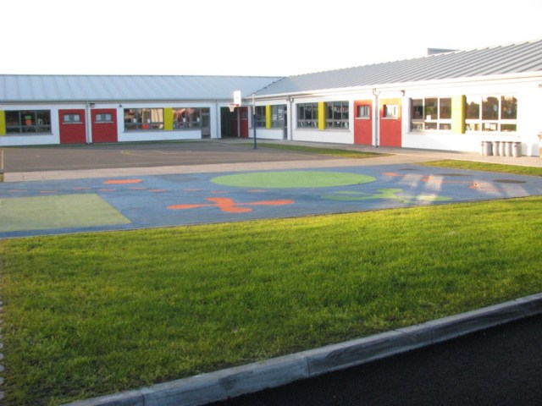

**Scoil Bhríde**

**Use of School Premises Policy**

External group use of the school premises for whatever purpose is dependent on compliance with the following directions:

1. Application in writing of proposed events to Principal/Chairperson of the Board of Management with all details, including proposed activity, number of people/children involved, duration of hire etc.
2. Evidence of appropriate insurance including public liability must be provided in writing to the Board of Management (unless the BOM agrees alternative arrangements), prior to the commencement of the event/activity. No loss must accrue to the Board of Management/Patron/Property Owners/Trustees and/or the Department of Education and Skills from the Organization/Body’s use of School’s facilities.
3. All proposed activities and events:

* will be subject to a health and safety review and insurance review.
* will (i) heed the advice of and (ii) must have the prior approval and endorsement of Scoil Bhríde Nurney’s school insurer.
* must provide written proof of a Health and Safety review and insurance cover (this in turn will be sent to Scoil Bhríde Nurney’s school insurer to be processed and assessed).

1. The nature of the activities for which the school is hired should be in keeping with the general educational aims and/or ethos of the school.
2. The standard and quality of organization, discipline and instruction (where it applies) should be in keeping with the professional standard of the school.
3. Where it applies, the quality of care towards and responsibility shown to children involved in specific activities should be in keeping with that of the school.
4. Date(s) must be agreed with BOM in advance.
5. Rooms will be assigned by the BOM.
6. A written agreement must be signed by BOM and the organizers of any event.
7. The supervision of children/adults attending activities is the responsibility of the teacher/instructor present on behalf of the group/individual hiring the school. (This includes the supervision and care of the clients waiting beforehand and waiting to be collected afterwards).
8. Any brochure/publicity should state that the event is not being run by the school authorities.
9. Responsibility rests with the group/individual who is hiring the school for communicating with parents/guardians/clients about:

(a) Starting/finishing dates and times

(b) Cancellations, re-scheduling etc.

(c) A contact phone number should be provided to parents/guardians/clients by the organizers through which all questions are directed. The school phone number is not to be provided as a contact number.

1. The teacher/organizer present on behalf of the group/individual hiring the school is responsible for:

* Health and Safety of participants.
* Ensuring that the school’s no smoking status is upheld.
* Ensuring that participants clearly understand that they are not permitted or authorized to access or enter any other rooms except the room being hired by the applicant and the corridor toilet. Any unauthorized entry will deem this agreement and contract null and void.
* Providing evidence of their Garda Vetting to the school (if applicable)
* Providing their Child Safeguarding/Protection Policy to the school (if applicable)
* Ensuring that the school’s no smoking status is upheld
* Turning off lights and closing all windows and doors used
* Returning equipment and furniture to proper storage point
* Re-arranging classroom furniture (if applicable)
* Arrange cleaning of toilets and any rooms used
* Any additional necessary cleaning (e.g, corridors, playground)
* All cleaning up afterwards. The facilities must be left in a clean and tidy condition in their original state and all property belonging to the group removed/stored as agreed.
* Make good any damages
* Provision of materials
* Due care in the use of any school equipment
* Setting the alarm and locking up the building and grounds (if requested to do so).
* Reporting any damage to property or equipment in writing to the Board of Management. The Patron/Board of Management/Property Owners/ Trustees reserves the right to recoup any costs incurred.

1. The teacher/organizer hiring the school and their participants are required to abide by signs on display, to adhere to school rules, health and safety requirements, including no smoking stipulations and to other relevant school policies, procedures and other measures in place to safeguard the safety and welfare of the school’s pupils/staff.
2. Requests made by the Board of Management representative on duty during meeting/activity times are to be complied with promptly and in full.
3. School property is to be vacated at the appointed times.
4. The group are required to comply with the school’s Safety Statement and Fire Evacuation Procedure and to confirm that they comply with all relevant legislative and other requirements including Health and Safety, Child Protection and Garda Vetting.
5. Any incidents which occur on school premises which could give rise to an insurance claim or which fall under the Health and Safety Policy must be reported to the Board of Management representative immediately or as soon as practically possible.
6. The principal and/or Board of Management will decide the limitation of numbers at any such meetings.
7. Meeting/activities can be held only at times sanctioned by the Principal/Board of Management.
8. The agreed school hire charges should be paid by cash or cheque to the Board of Management of Scoil Bhríde Nurney, before the commencement of the event/activity. The rate will be decided on a case-by-case basis.
9. The school reserves the right to use the room for its own purposes.
10. The BOM will periodically review the hire of the school premises and should the need arise, to suspend the hire should they deem it necessary. The school reserves the right to discontinue the use of the hall/room at any time for any specific reason. The principal will have responsibility for monitoring/overseeing the process and will report to the Board of Management accordingly.
11. There shall be no disruption to any teacher, child or staff member. The group shall use their own resources unless specifically requested otherwise e.g., computers. They will have the use of the specific room which approval has been requested and granted only.
12. All course activity organizers shall be responsible for their own tax liabilities. They will provide a tax clearance certificate with their application for use of the school premises.
13. The organizers are responsible for familiarizing themselves with all Health and Safety Procedures.
14. All course organizers shall receive this policy and shall sign it thus agreeing to the aforementioned.
15. All course organizers shall receive, read and sign the attached contract (which forms part of this policy) for the rental/leasing of premises for Scoil Bhríde Nurney
16. This agreement will be valid, subject the above conditions, for one year.
17. The Organization/body is responsible for ensuring that all members using school facilities are aware of these conditions.

I/we _____________________________________ agree to these rules and procedures for my/our ___________________________________running on ___________________ (indicate dates).

I/we have provided: *(please tick)*

* Evidence of appropriate insurance including public liability is provided in writing to the Board of Management.
* A specific indemnity from my/our insurer to the BOM, Trustees and Patron of Scoil Bhríde in respect of the use of the school premises.
* Evidence of Garda Vetting to the school (Applicable/Not Applicable)
* A Child Protection Policy is available to the school (Applicable/Not Applicable)
* Confirmation that I/we have child safeguarding measures in place
* A tax clearance certificate.
* The signed contract below agreeing to all the above terms and conditions

Signed by renter: ___________________________ Date: _________________

###### CONTRACT

###### For the rental/leasing of premises for Scoil Bhríde Nurney

|  |  |  |  |  |
| --- | --- | --- | --- | --- |
| Name of Hiring Group |  | | | |
| Address |  | | | |
| Phone | Mobile |  | Landline |  |
| Email |  | | | |
| Purpose for which the premises will be used |  | | | |
| Number of participants |  | | | |
| Period of rental | From |  | To |  |
| Rental details  (e.g. day, start time, finish time, how many days per week etc.) |  | | | |
| Insurance company  (please enclose copy of policy) |  | | | |
| Contact person |  | | | |
| Phone |  | | | |
| What security arrangements are in place regarding access to the building? |  | | | |
| What arrangements are in place to secure Data on individual children and staff |  | | | |
| What arrangements are in place regarding child protection and Garda vetting |  | | | |

* I will pay the *Board of Management of Scoil Bhríde Nurney* the agreed rate of €________per week/day *(delete as appropriate)* for the duration of the rental period.

**Cheques only and payable in advance to *“Board of Management of Scoil Bhríde Nurney”***

(As per Department of Education guidelines *“any provision should be self-financing and should, at a minimum, cover maintenance, utility bills, additional insurance costs, legal requirements and other overheads or associated costs” e.g. opening up, locking up, light and heat etc.)*

* I confirm that the premises is suitable for the delivery of my service/activity
* I undertake to repair any damage to the premises and equipment and return it to its former state.
* I will ensure that all school equipment is kept safely and properly stored.
* I agree to use only the room(s) agreed in advance
* I agree that the school premises will only be used for the activities agreed in advance.
* I agree in full to the rules and procedures outlined in Scoil Bhríde’s “Use of School Premises Policy”

Any changes in these activities should be agreed in writing with the Board of Management.

Signed by renter: ___________________________ Date: _________________

Signed on behalf of the BOM: __________________ Date: __________________

**Ratification of Use of School Premises Policy**

This policy was adopted by the Board of Management on _________________

Signed: _________________________ Signed: __________________________

Chairperson of Board of Management Principal

Date: __________________________ Date: __________________________

Date of next review: __________________